Design brush-ups: November 29, 2011:

-Text not vertically centered, I don't think that is a topic of forefront issue, not sure if we decided to give pictures of the static texts? (Ask Nora)

-Menu button still bugged, I believe this is on the not-top-priority list though.

-Long-press is only applied on release, instead of after several seconds of pressing.

Login screen:

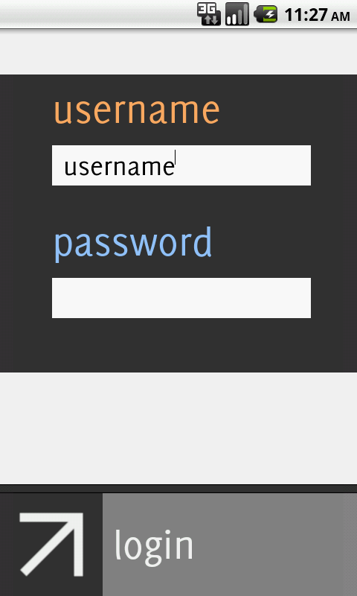

The default text "username" under the username heading is not needed

Confirmation screen:

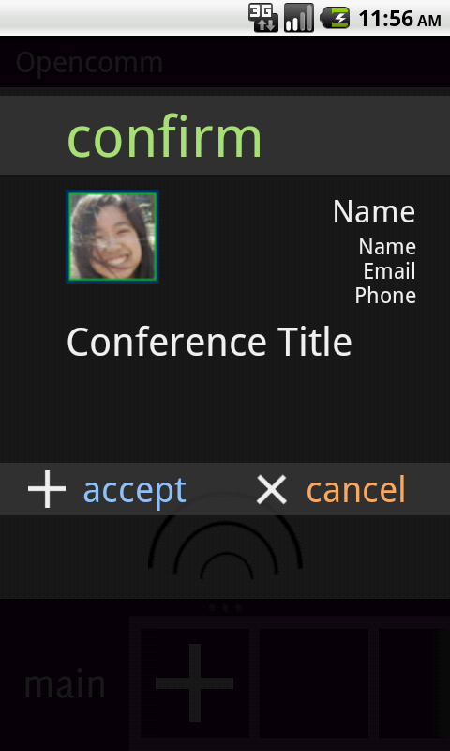

Icon size is too small, should be 100x100. Style is also in all lower-case letters

The heading "confirm" is placed too high. The top of the grey overlay covering the heading should be 140px from the very top of screen (or 102px from the bottom of the Android bar). I think as a result, everything will be shifted down and that should be correct.

This is also applicable to the other screens using this type of 2 button and 1 button overlay (Although the tips screen will be phased out, so don't worry about that)